EC2-TASKS

1. Launch one EC2 using Amazon Linux 2 image and add a script in user data to install Apache.

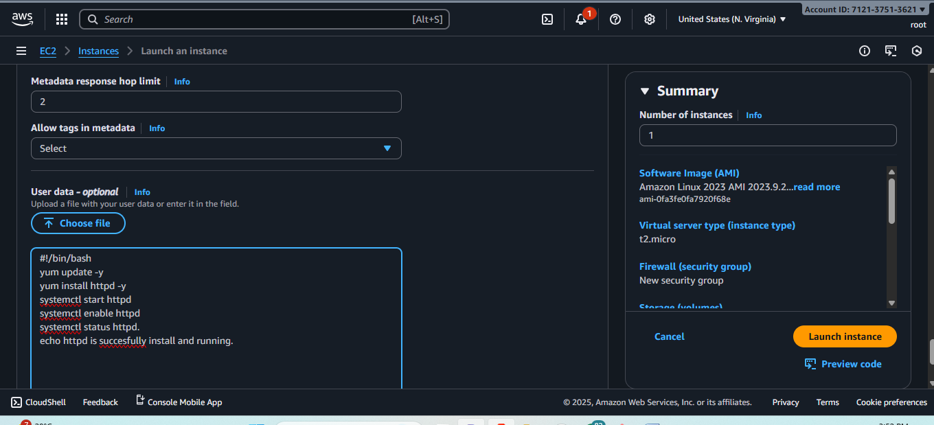

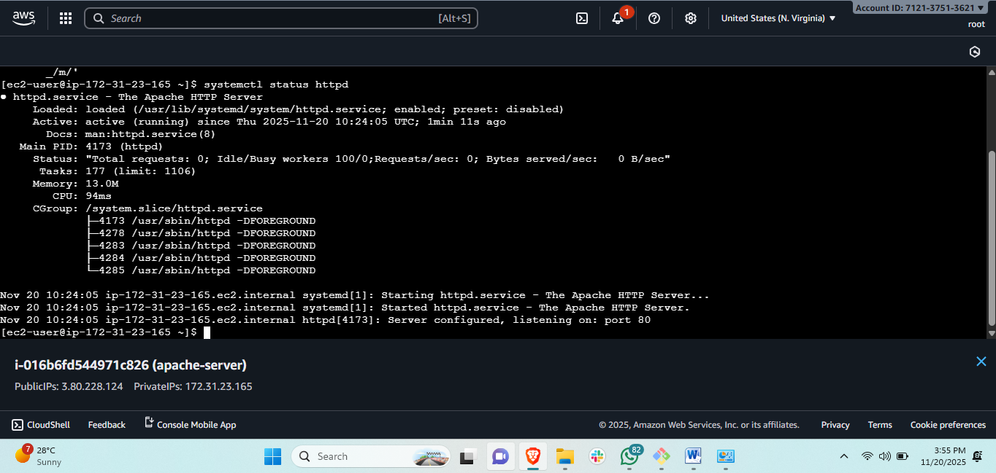

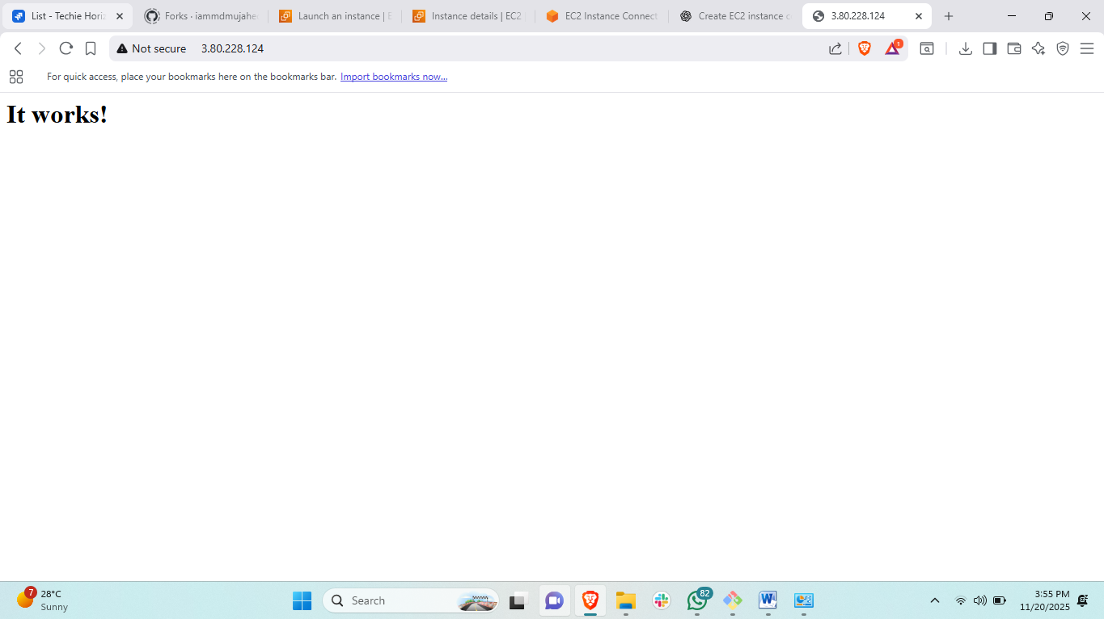

1. Launch one EC2 using Ubuntu image and add a script in user data to install Nginx.

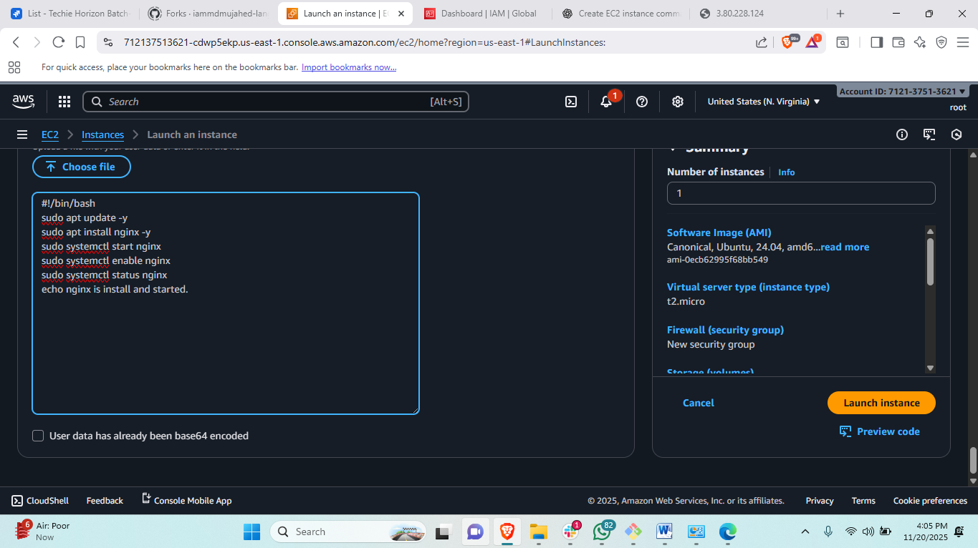

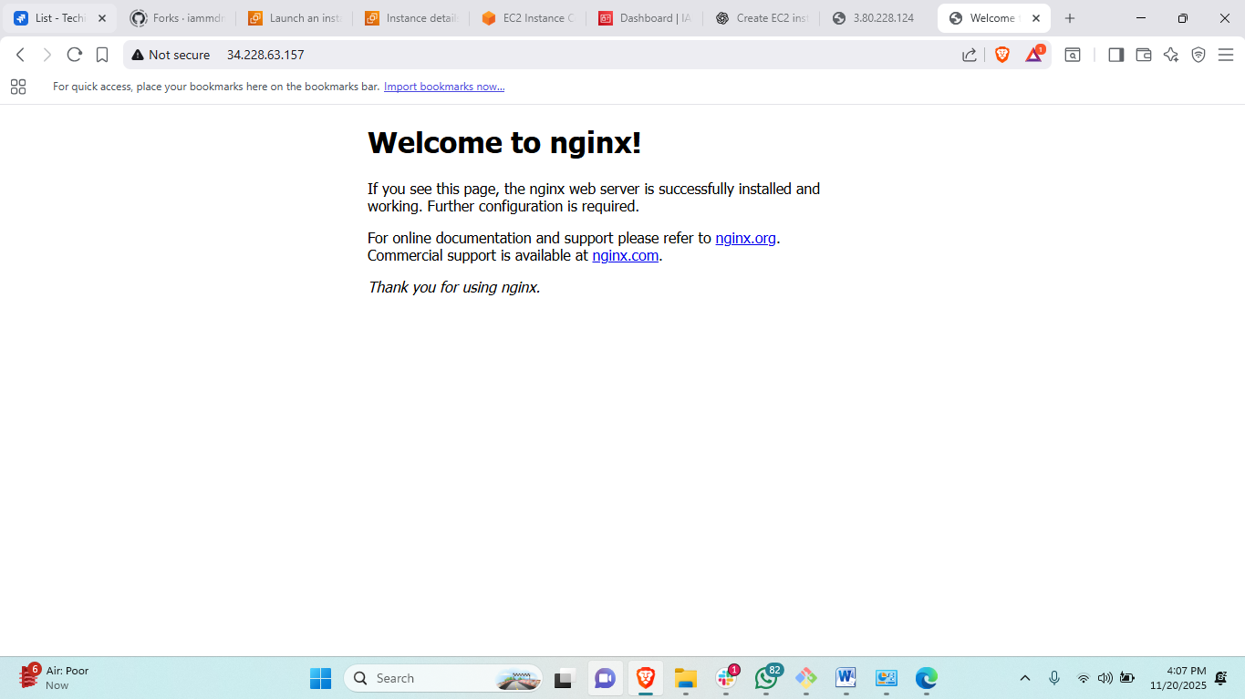

1. Launch one Windows server and install Tomcat on Windows.

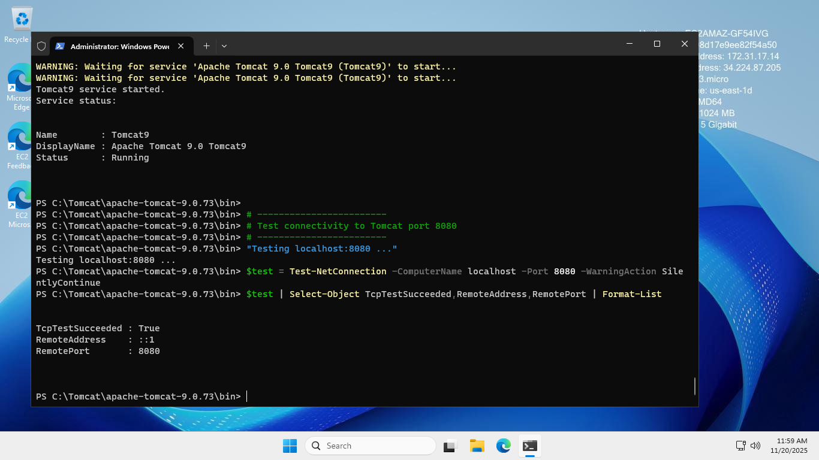

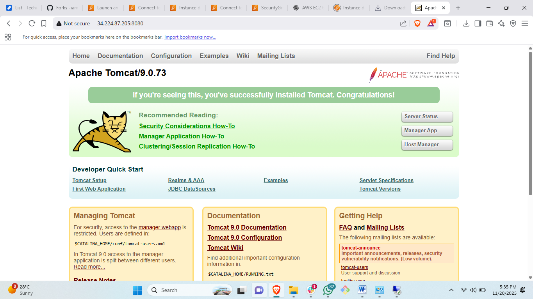

Steps: first connect the windows server through RDP and then open powershell in windows.

# then some commands to intall tomcat in windows powershell follow the guideline through chat gpt

1. Take a snapshot of the instance created in Task 1.

Concept: we are taking the snapshot of created instance because, if we loss or accidentely terminated our instance then the snapshot will use to backup our terminated instance in new instance.

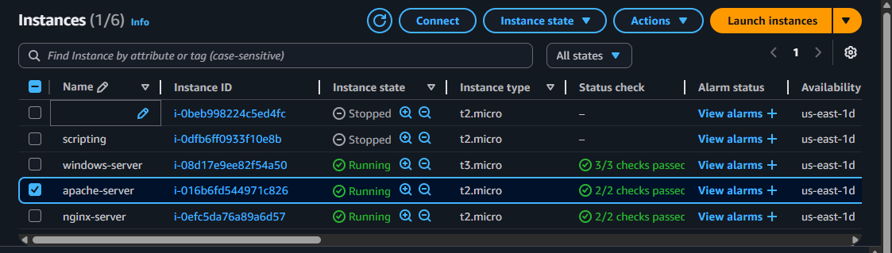

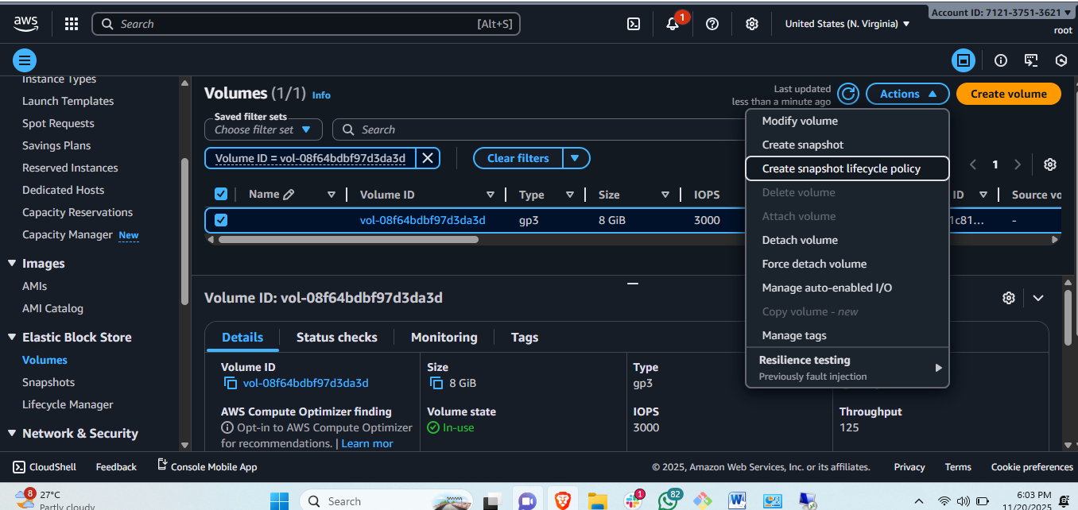

Steps: go to instances and select the instance and scroll down and click on staorage and over there volume will be there.  
#select to that volume and and go to actions and the snapshots will be there

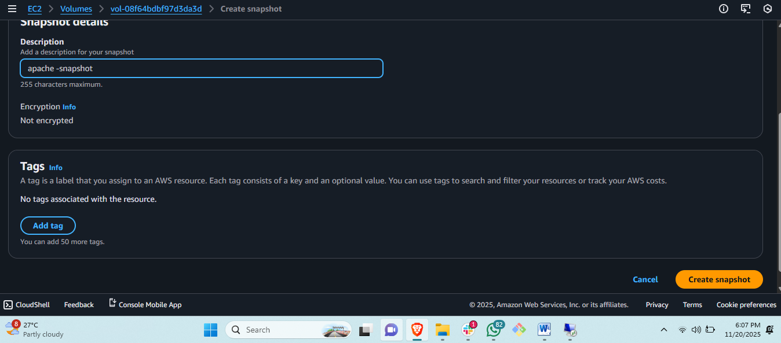

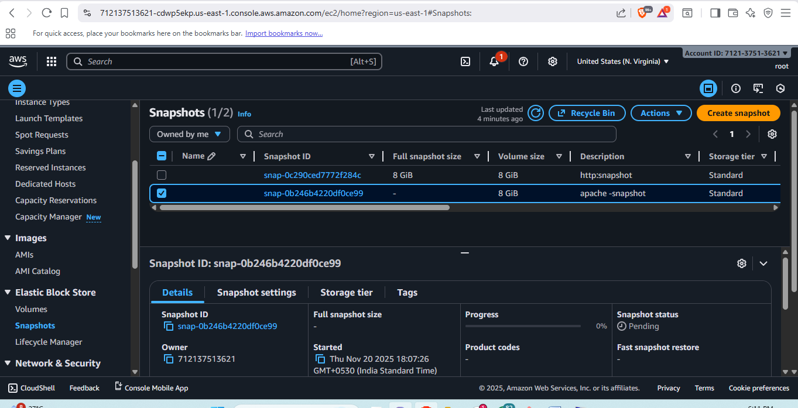

1. Assign passwordless authentication for the EC2 created in Task 2.

First: generate pe-key ands copy this and open our nginx server and   
# THEN <CD .SSH> and <ls>

#then vi authorized file > and paste the copied pem-key in this authorized file.

#then copy public ip of nginx server and username.

#open git bash and ssh ec2-user@pubip.

#it will connect passwordless.

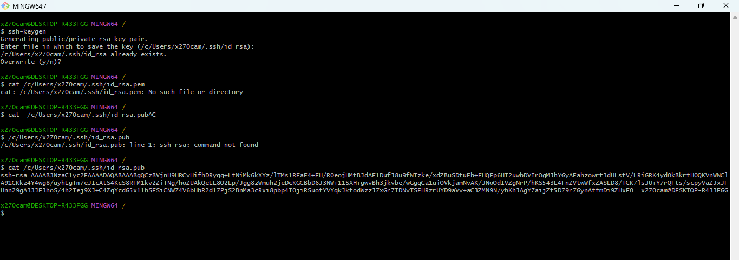

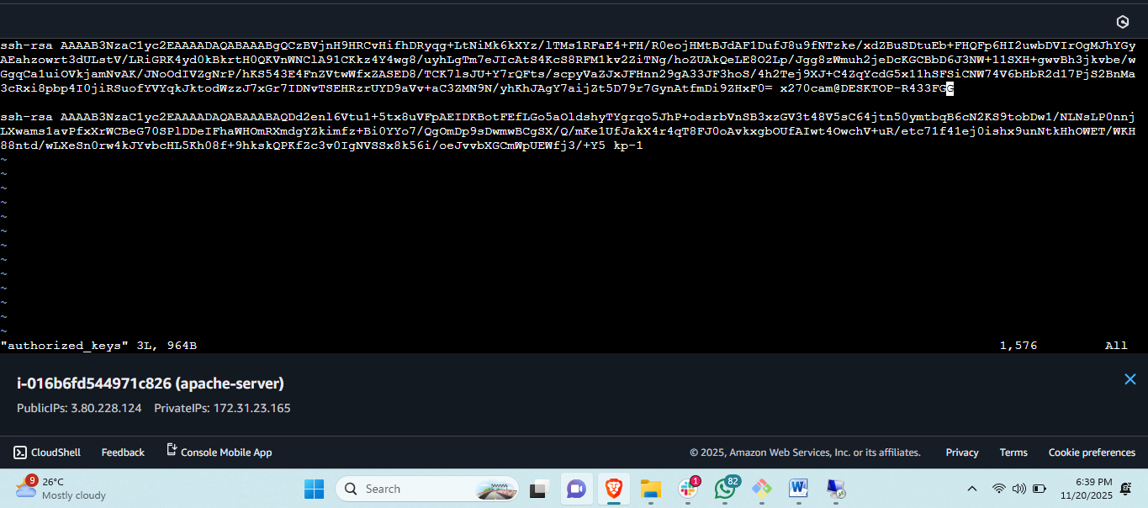

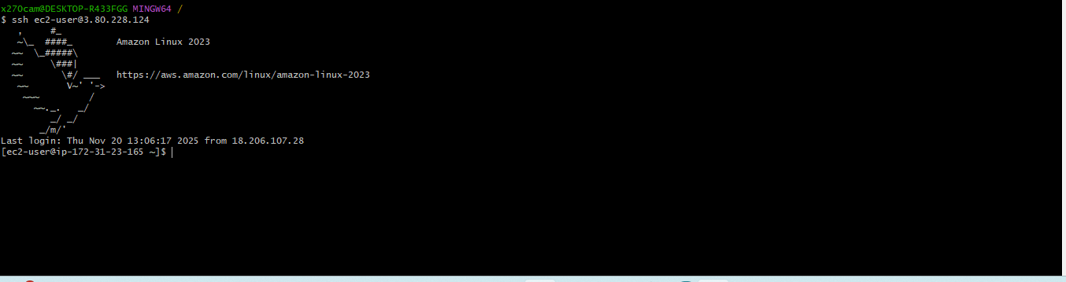

1. Launch any EC2 using the spot purchasing option.

Concept of spot instance: spot instance is a type of instance which is cheaper than all instance type and it can purchase on bidding.

Drawback of spot instance: it can be terminate or loss any time if anethor client is paying more money then it will be terminated from us.





Steps:first we click on create instance go to advanced by scroll down.

#then select spot instance and select your maximum bidding amount.



1. Enable termination policy on the EC2 created in Task 2.

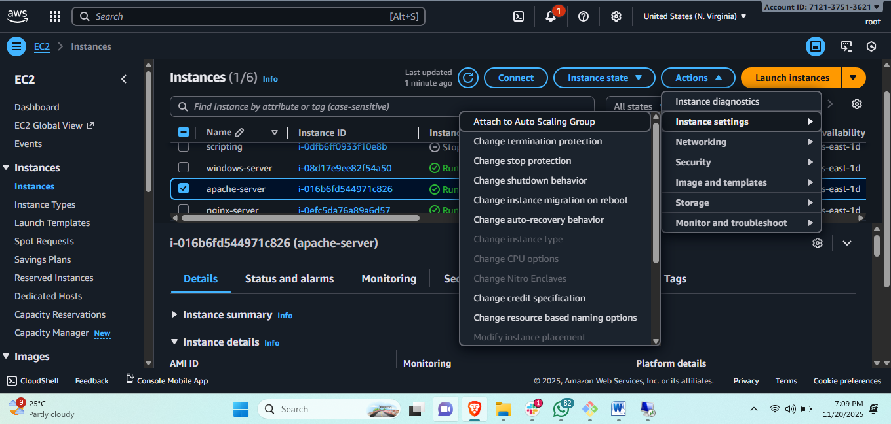

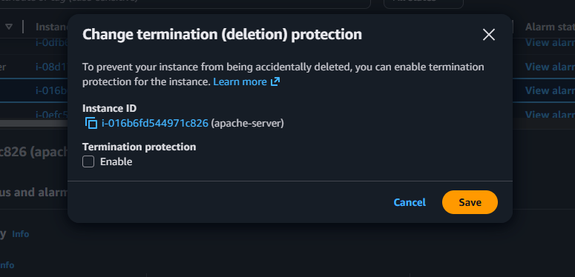

1. Launch one EC2 using AWS CLI.



First we need to configure AWS CLI through google browser.

#then we need open girt bash and <aws configure> then it will ask for access key and pass.

#

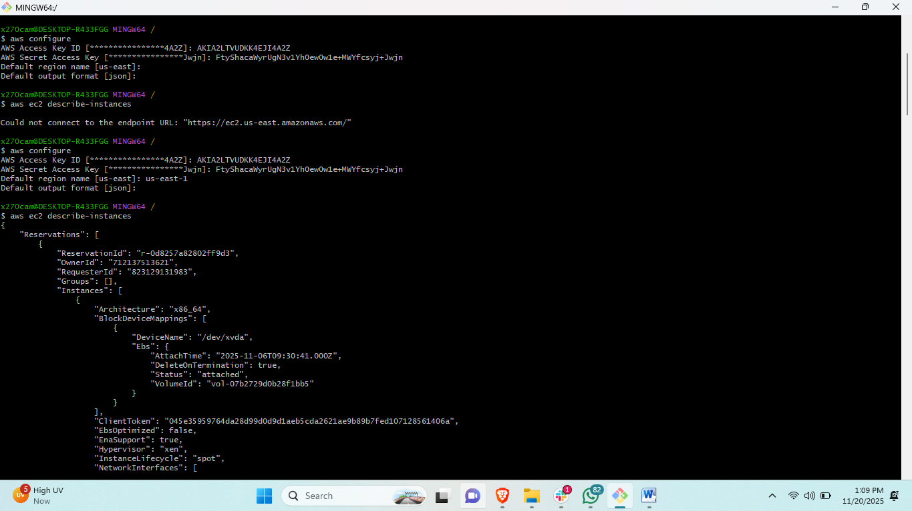

Steps: first <aws configure> for connecting aws account.

#then paste access key and private key both.

# 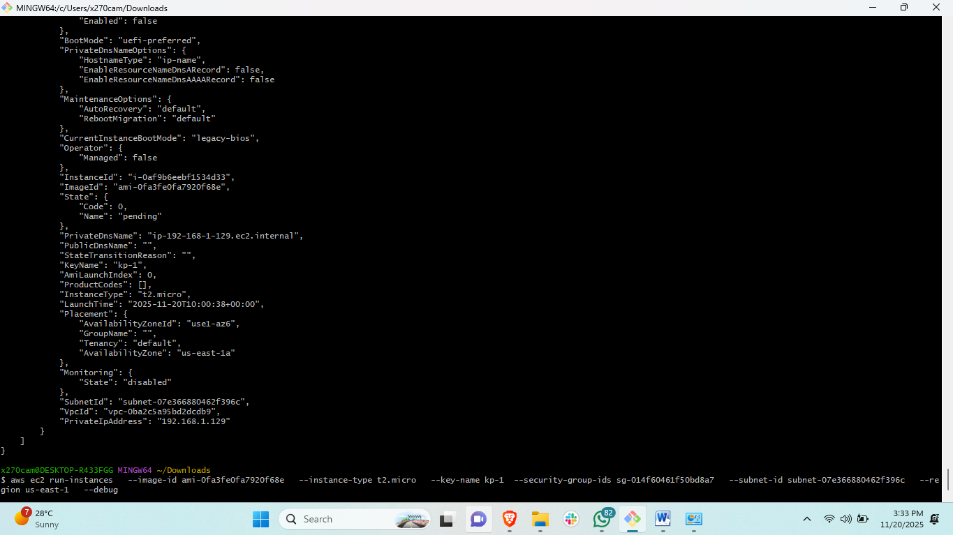

#aws ec2 run-instances \

--image-id ami-0fa3fe0fa7920f68e \

--instance-type t2.micro \

--key-name cli-key \

--security-group-ids sg-04fbd9a6977c01158 \

--subnet-id subnet-07e366880462f396c \

--region us-east-1 \

--debugaws ec2 run-instances \

--image-id ami-0fa3fe0fa7920f68e \

--instance-type t2.micro \

--key-name cli-key \

--security-group-ids sg-04fbd9a6977c01158 \

--subnet-id subnet-07e366880462f396c \ --region us-east-1 \

--debug.   
  
  
\.........check each and every thing should be correct.

